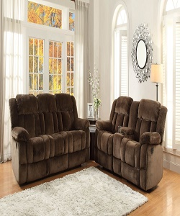

Modern Living room set

$137.25

Availability: In stock

Description

Rosewood collection chocolate champion fabric double reclining sofa and Love

Seat set. It gives you traditional / transitional look. It is available in 6 fabrics, including three lather fabric. It velvet like fabric which gives you soft and relaxing feel.